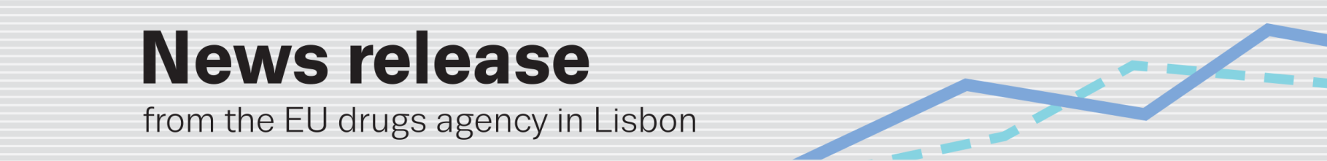
2014 emcdda scientific paper award — LISBON
Annual award ceremony to celebrate excellence in scientific writing on illicit drugs
(24.11.2014, LISBON) The four winners of the 2014 EMCDDA scientific paper award will be honoured in Lisbon on 25 November at the fourth annual award ceremony hosted by the EU agency (¹). The winners will receive a non-monetary prize for their contributions in the margins of the third ‘Reitox week’ initiative, which gathers representatives from around 40 national drug monitoring centres (²).
The prize, inaugurated in 2011 by the EMCDDA and its Scientific Committee, celebrates scientific writing and distinguishes high-quality research in the field of illicit drugs. This year, a record 64 papers were nominated by members of the Scientific Committee, the Reitox national focal points, European drug research peer-reviewed journals and by EMCDDA staff. The jury was composed of members of the Scientific Committee, the International Society of Addiction Journal Editors (ISAJE), other acknowledged scientists in the drugs field and EMCDDA senior scientific staff.
According to the entry criteria, all articles were published in peer-reviewed scientific journals in 2013, with the primary author being based in, or a national of, an EU Member State, Turkey or Norway. Papers could be submitted in the following categories: basic biological, neurobiological and behavioural research; population-based research and clinical epidemiology; demand reduction; drug policy; and supply, supply reduction and crime research. The 2014 winners (primary authors) are:
- ‘Amphetamine actions at the serotonin transporter rely on the availability of phosphatidylinositol-4,5-bisphosphate’ (2013), primary author Dr Florian Buchmayer (Austria, represented at the event by co-author Prof. Harald H. Sitte). Published in Proceedings of the National Academy of Sciences of the United States of America, 110, 28, p. 11642–47.
- ‘Substance use disorders in adolescents with attention deficit hyperactivity disorder: a 4-year follow-up study’ (2013), primary author Annabeth Groenman, MSc (Netherlands). Published in Addiction, 108, 8, p. 1503–11.
- ‘Defining substance use disorders: do we really need more than heavy use?’ (2013), primary author Prof. Jürgen Rehm, PhD (Germany). Published in Alcohol and Alcoholism, 48, 6, p. 633–64.
- ‘Building a European consensus on minimum quality standards for drug treatment, rehabilitation and harm reduction’ (2013), primary author PD Dr Michael P. Schaub (for a paper written in the framework of EQUS, an EC-funded project)(³). Published in European Addiction Research, 19, 6, p. 314–24.

Chair of the EMCDDA Scientific Committee Prof. Dr Gerhard Bühringer said: ‘The EMCDDA Scientific paper award promotes excellence in academic publishing and supports major advancements in the drugs field, thereby contributing to improvements in policy and practice. The growing number of nominations for the award from all over Europe reaffirms its high reputation and the role of EMCDDA and its Scientific Committee in promoting research around this important issue’.
Award ceremony: 17.00–19.00 — Tuesday 25 November, Praça Europa 4 (open to the press).
(¹) www.emcdda.europa.eu/activities/scientific-paper-award
(²) www.emcdda.europa.eu/news/2014/third-reitox-week
(³) http://ec.europa.eu/justice/anti-drugs/files/equs_main_report_en.pdf

