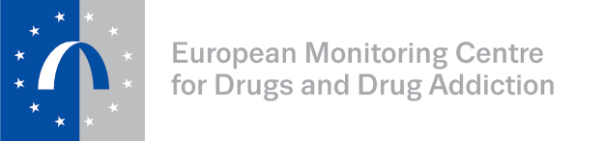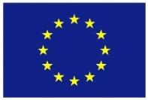
Funded by the
European Union

European Drugs Summer School 2019: support for participants from
European Neighbourhood Policy countries

Four bursaries are offered through the EU-funded project EU4Monitoring Drugs (EU4MD)
to professionals, academics or experts wishing to participate in the European drugs summer school (EDSS) this year.
The eligible candidates are early-career professionals, experts and postgraduate students from European Neighbourhood Policy countries: Algeria, Armenia, Azerbaijan, Belarus, Egypt, Georgia, Israel, Jordan, Lebanon, Libya, Moldova, Morocco, Palestine*, Tunisia
and Ukraine.
The bursaries will cover the flight, accommodation and the EDSS fees. The course is conducted in English and participants should have a good written and oral knowledge of the language.
The deadline for applications is 30 April 2019.
Successful candidates will be notified by 10 May 2019.
The application should be submitted by e-mail to: EU4MD_pct@emcdda.europa.eu
(please add drugsummerschool.cies@iscte.pt in copy)
Eligibility criteria
Support will be awarded having the following criteria in mind:
- scientific/professional excellence — the scope and achievements of the academic and/or professional practice of the applicant in accordance with their career stage (even at early stages) and the opportunities afforded by their sector and/or home country context (checked through the CV);
- motivation to be engaged in the debate on drugs and related problems and to act as a multiplier in the country of origin (checked through the motivation letter);
- showing professional activity and potential impact in the country of origin
(CV or motivation letter);
- good English-language skills.
* This designation does not entail any recognition of Palestine as a state and is without prejudice to positions on the recognition of Palestine as a state.

Application form for bursary

All fields are mandatory. The application form should be filled in in English.

1. Participant eligibility
- Name:
- Surname:
- E-mail:
- Highest academic qualification:
- Current organisation name:
- Position/role in organisation:
- Country: Choose an item. If you choose ‘other’ please specify: ___________________________

2. Personal data
- Name (as stated in the ID document you use for travelling):
- Surname(s) (as stated in the ID document you use for travelling):
- Title: Choose an item.
- Date of Birth: dd/mm/yyyy: Type of ID document you use for travelling: Choose an item.
- Country issuing your ID document:
- Number of ID document you use for travelling:
- ID document valid until: dd/mm/yyyy:

3. Travel requirements
- City of departure to travel to Lisbon:
- Will you need visa to travel?
☐Yes*
☐No

* Please note that you will have to make your own arrangements for visa application.
We will only provide a letter of invitation as a supportive document.

5. Letter of motivation (max 1 500 characters).


6. Short resumé (max 4 500 characters)

The application should be submitted by e-mail to: EU4MD_pct@emcdda.europa.eu
(please add drugsummerschool.cies@iscte.pt in copy).

