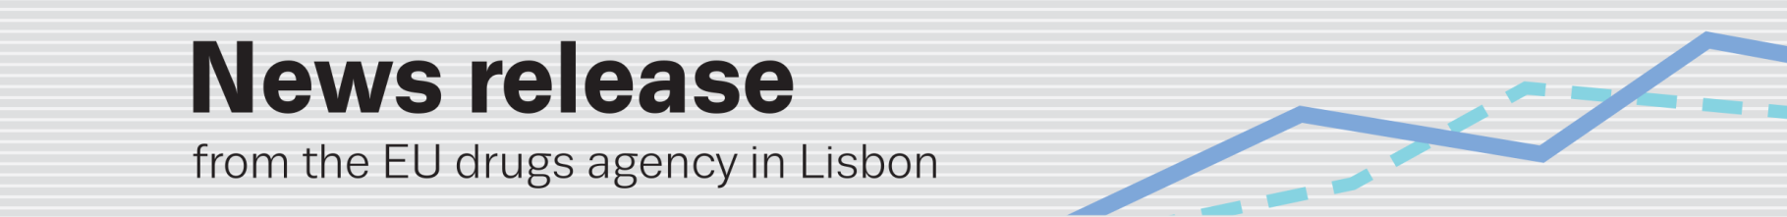
26 june: International day against drug abuse and illicit trafficking
EMCDDA releases state-of-the-art review on drugs and driving
(25.6.2014, LISBON) An estimated 28 000 lives are lost on Europe’s roads every year and a further 1.34 million people are injured (¹). Many of these accidents and deaths are caused by drivers whose performance is impaired by a psychoactive substance. Alcohol remains the number one substance endangering lives on European roads, but use of drugs and medicines behind the wheel, particularly when combined with alcohol, is a major challenge for policymakers. In a new report out today, Drug use, impaired driving and traffic accidents, the EU drugs agency (EMCDDA) reviews the latest research in this field (²).
‘Alcohol, especially in high concentrations, must remain the principal focus of prevention measures’, says the EMCDDA. But it calls for combined drug and alcohol use by drivers to be addressed ‘more intensively’, given its association with a ‘very high risk of a traffic accident’. The report states: ‘Statistically, the use of amphetamines, cannabis, benzodiazepines, heroin and cocaine is associated with an increased risk of being involved in and/or being responsible for an accident, and in many cases, this risk increases when the drug is combined with another psychoactive substance, such as alcohol’.
Released ahead of International day against drug abuse and illicit trafficking (26 June), the report updates a literature review published by the agency in 2008. The new edition includes the results of the European Commission-funded DRUID project (2006–11), which contributed key evidence to road safety policy by mapping Europe’s drink- and drug-driving problem across 13 countries (³). Also examined are over 500 studies, published in Europe and internationally up to 2013, with a greater emphasis placed on meta-analyses and systematic reviews, which combine and summarise the most recent findings. The research is split into two study types: epidemiological (e.g. roadside surveys) and experimental (e.g. performance tests).
The report reveals how cannabis (THC) is the most frequently detected illicit drug in drivers (followed by cocaine and amphetamines) and benzodiazepines the most frequently found medicine. Large differences are observed among countries, with more alcohol and illicit drugs found in southern Europe and more medicinal drugs in northern Europe.
The report explores methodology, prevalence and the effects of substances on performance. It concludes: ‘The chronic use of all illicit drugs is associated with some cognitive and/or psychomotor impairment and can lead to a decrease in driving performance even when the subject is no longer intoxicated’. Among concerns raised in the report is the variety of drugs available today: ‘The range of psychoactive substances available for illicit use is increasing, and recent studies are finding evidence of their use among drivers’.
EMCDDA Director Wolfgang Götz says: ‘We are all aware of the link between alcohol and road traffic accidents and this is reflected across Europe in a robust policy response to the problem. Less well understood, and of growing importance for future policy development, however, is how the use of other psychoactive substances may affect driving performance. As drug consumption patterns change, particular concerns arise. These include: an ever-expanding range of psychoactive substances and medicinal products as well as context-specific risks such as those posed by young people driving home from nightlife venues after consuming a mix of alcohol and drugs’.
Götz adds: ‘Today’s report provides a state-of-the-art review of the growing evidence base on substance-impaired driving. I am convinced that it will not only prove a timely, and much-needed, tool for understanding this rapidly-evolving area, but also facilitate the development of more comprehensive road safety policies’.
The prevention of driving under the influence of drugs is one of the priorities outlined in the current EU drugs action plan (2013–16).

Notes
(¹) EC Road Safety Statistics http://ec.europa.eu/transport/road_safety/specialist/statistics/index_en.htm
(²) www.emcdda.europa.eu/publications/insights
(³) For more on the DRUID project, see www.druid-project.eu

International day against drug abuse and illicit trafficking: The EMCDDA marks this day with an event at its premises for the Lisbon diplomatic community and its partners from the Portuguese authorities. The United Nations Office on Drugs and Crime will be launching its 2014 World Drug Report and promoting its World Drug Campaign (www.unodc.org/drugs). Other EMCDDA publications available today: General Report of Activities 2013; A year in review 2013; Drugnet Europe 86 (www.emcdda.europa.eu/publications). For more on drugs in Europe, see European Drug Report 2014 package (www.emcdda.europa.eu/edr2014).

