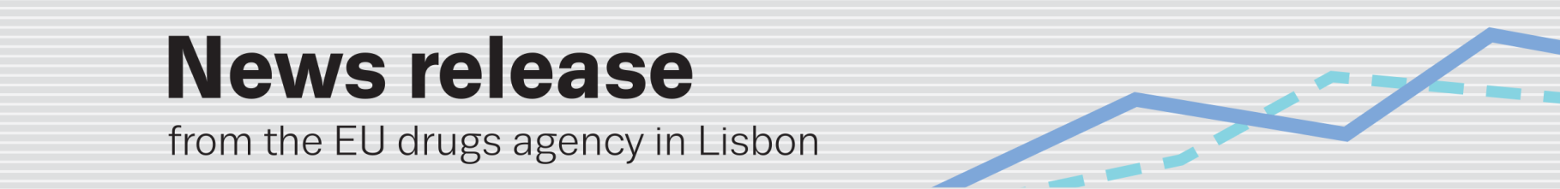
latest annual trends report from the emcdda
EU drugs agency to launch European Drug Report 2014
(24.4.2014, LISBON) The EU drugs agency (EMCDDA) will be presenting its annual overview of the European drug situation on 27 May in a multilingual, multimedia information package focusing on today’s rapidly shifting drug phenomenon.
Central to the package is the European Drug Report 2014: Trends and developments (in print and online in 23 languages), summarising the latest trends across the 28 EU Member States, Turkey and Norway. This top-level analysis explores: drug supply; drug use and drug-related problems; health and social responses to drug problems; and drug policies.
Accompanying the report will be Perspectives on drugs (PODs), online interactive analyses providing insights into six topical issues (including cannabis markets in Europe and Internet-based drug treatment). The information package will be completed by the European Drug Report: Data and statistics and Country overviews offering national-level data and analyses.
A tablet version, including interactive maps and graphics, will be available in English. Audiovisual material will also be on offer.
For more, see www.emcdda.europa.eu/edr2014
- Launch date: Tuesday 27 May 2014
- Time: 10:00 Western European Time (Lisbon) (11:00 Central European Time)
- Press conference venue: EMCDDA, Cais do Sodré, 1249-289, Lisbon
- Interviews: EMCDDA representatives will be available on the day of the launch in Lisbon to answer journalists’ questions. Across Europe, staff at the Reitox national focal points will answer country-specific queries (interview details available at above link)
- Social media: twitter.com/emcdda • www.facebook.com/emcdda
- Subscribe to our RSS newsfeed: www.emcdda.europa.eu/rss

