
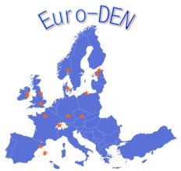

Euro-DEN Plus Baltic Regional Meeting

Hilton Tallinn Park, 9-10 March 2017

Thursday 9th March 2017

14:00 - 14:15 | Opening of the Meeting and Introductions | Paul Dargan / All
14:15 - 15:00 | Overview of the Euro-DEN Plus Project | Paul Dargan
15:00 - 15:30 | Euro-DEN Plus: the EMCDDA Perspective | Isabelle Giraudon
15:30 - 16:00 | Coffee Break
16:00 - 16:30 | Euro-DEN Plus NPS presentations | David Wood
16:30 - 17:00 | Euro-DEN Plus Benzodiazepine Presentations | Chris Yates
17:00 - 17:30 | Euro-DEN Plus: Data from the Estonia Centres | Raido Paasma
17:30 - 17:45 | Discussion with the National Focal Point and Forensic Toxicologists from Estonia
17:45 - 18:00 | General Discussion | All

Friday 10th March 2017

09:00 - 10:30 | Overview of the Euro-DEN Plus Data Collection System | Alison Dines
10:30 - 11:00 | Coffee Break
11:00 - 12:00 | Discussion of Euro-DEN Plus data collection in the Baltic Region  Timeline and work plan for contribution of the new centres | Roundtable

