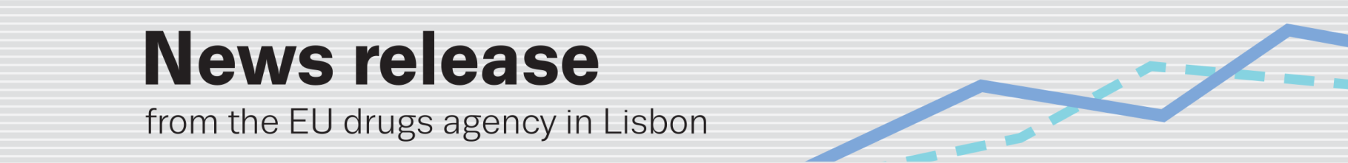
upcoming changes at the EU drugs agency
EMCDDA Management Board selects new Director
(10.9.2015, LISBON) Alexis Goosdeel (Belgium) was selected today to become the new Director of the Lisbon-based European Monitoring Centre for Drugs and Drug Addiction (EMCDDA).
Following a public recruitment procedure (¹), the agency’s Management Board, meeting in Lisbon this week, interviewed three candidates short-listed for the post in July by the European Commission. Mr Goosdeel was elected by over a two-thirds majority by secret ballot.
Before being formally appointed by the Board, Mr Goosdeel will be required to make a statement before the European Parliament later this month and to answer questions put by members of the Civil Liberties, Justice and Home Affairs Committee (LIBE).
Fifty-five-year-old Mr Goosdeel is expected to take up the post on 1 January 2016. He will succeed Wolfgang Götz (Germany), who has headed the agency since 1 May 2005 and who will remain Director until the end of the year.
Mr Goosdeel joined the EMCDDA in 1999 as a project manager working in the area of EU enlargement and international cooperation. Since 2005, he has been Head of the agency’s Reitox and international relations unit. In this capacity, he has played a central role in: coordinating a network of 30 national drug monitoring centres; preparing EU candidate and potential candidate countries for membership of the EMCDDA; preparing future cooperation with neighbouring countries to the EU; and nurturing relations with countries beyond the Union (Central Asia, Russia, Latin America).
He has spent much of his 30-year career working in the field of public health at national, European and international level. He was one of the founders of Modus Vivendi, a Belgian NGO working in the area of harm reduction. Before joining the agency, Mr Goosdeel directed the Brussels-based Alizés, a European association working for development and cooperation in public health (1992–99).
Mr Goosdeel holds a Master’s degree in clinical psychology and a special diploma in advanced management. He is proficient in six languages: French (mother tongue); English, Spanish, Greek, Portuguese and Dutch.
Note to editors
(¹) http://eur-lex.europa.eu/legal-content/EN/TXT/PDF/?uri=OJ:C:2015:022A:FULL&from=EN
The EMCDDA Director is the legal representative of the agency and is accountable to the Management Board, the agency’s main decision-making body. Appointed for a renewable five-year period, the Director is responsible for the day-to-day running of the agency (work programmes, budget, staff). The Management Board comprises one representative of each EU Member State, two representatives of the European Commission and two persons designated by the European Parliament.

The EMCDDA’s aim is to provide the EU and its Member States with ‘factual, objective, reliable and comparable information at European level concerning drugs and drug addiction and their consequences’. Formally established in 1993 and operational since 1995, it is currently celebrating 20 years of monitoring.

