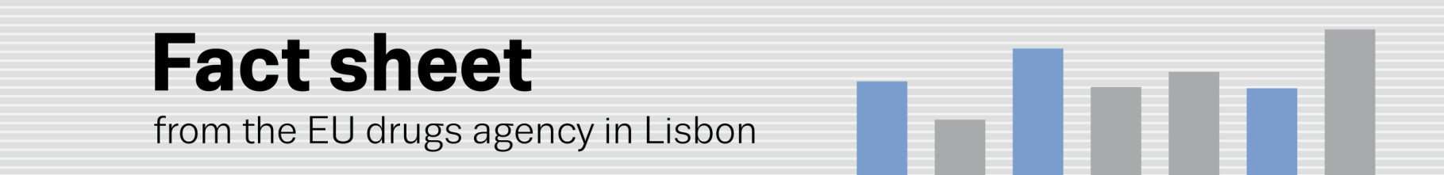
Testing the waters II: second international conference on wastewater analysis
EMCDDA co-hosts ‘Testing the waters 2015’
(9.10.2015, LISBON) The EU drugs agency (EMCDDA) is co-hosting next week in Ascona, Switzerland, the second international conference on wastewater analysis: ‘Testing the waters 2015’ (¹). The event, to be held from 11–15 October, is organised by the Swiss Federal Institute of Aquatic Science and Technology (Eawag), in association with the EU-funded SEWPROF project and the Europe-wide sewage analysis CORE group, SCORE. It also counts on generous support from the Centro Stefano Franscini (CSF/ETHZ) (²). The conference follows on from Testing the waters I, organised by the EMCDDA in Lisbon in 2013 (³).
Wastewater analysis is a rapidly developing and novel scientific discipline with the potential for monitoring near-real-time, population-level trends in illicit drug use. By sampling a known source of wastewater, such as a sewage influent to a wastewater treatment plant, scientists can now estimate the quantity of drugs used in a community by measuring the levels of illicit drugs and their metabolites excreted in urine.
While wastewater analysis does not provide the type of individual consumption data currently yielded by drug surveys, its ability to pinpoint total consumption rates in a given population makes it a useful complement to existing methods for studying drug use trends.
Over 80 participants from some 20 countries will attend the conference and explore the following areas:

Monitoring studies: targeted sampling at local, regional, national and international scale; integrating wastewater results with other epidemiological data

Methodological improvements: quantifying and reducing uncertainty of back-calculation, monitoring design and in-sewer transformation

Advances in analytical chemistry: method refinements and ability to measure new substances

Ethical and legal aspects: discussion of settings requiring special attention

Innovative applications: wastewater analysis for community-wide health assessment beyond illicit drugs
The conference will hear presentations on the latest research findings and technical advances in the field and identify information gaps and future research needs. The EMCDDA, which sits on the organising and scientific committee of the conference, will describe its work in this domain and preview its upcoming publication Assessing illicit drugs in wastewater (⁴) to be released this autumn. It will also present an award for the best poster at the event.
Research into wastewater analysis is of increasing interest worldwide and a trans-disciplinary approach is essential for its development. For this reason, the conference will combine the varied perspectives of: analytical chemistry, biochemistry, environmental and sewage engineering, forensic science, pharmacokinetics, spatial epidemiology, statistics and drug epidemiology.
(¹) Testing the waters II: http://testingthewaters2015.ch (²) http://www.eawag.ch/en/ — http://sewprof-itn.eu — www.score-cost.eu — http://www.csf.ethz.ch/ (³) http://www.emcdda.europa.eu/events/2013/testing-the-waters (⁴) EMCDDA upcoming publications http://www.emcdda.europa.eu/publications/upcoming

