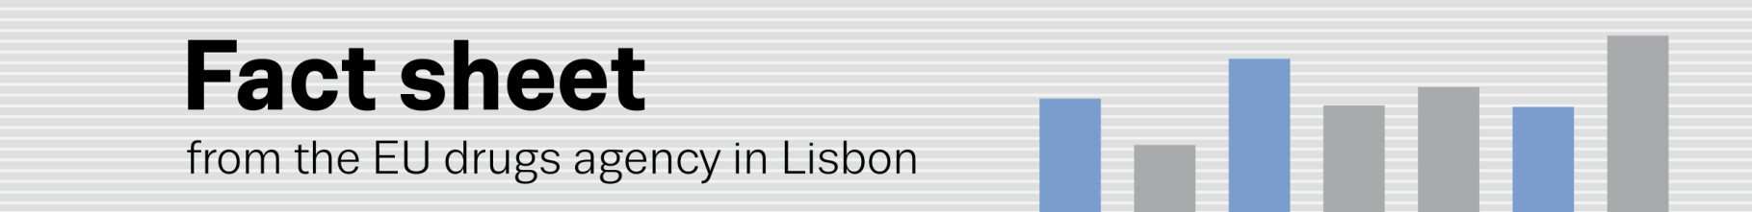
united nations general assembly special session on drugs 2016
EMCDDA to join EU delegation at UNGASS 2016 in New York
(18.4.2016, LISBON) The 2016 UN General Assembly Special Session (UNGASS) on drugs will convene at the UN headquarters in New York from 19–21 April (¹). This meeting — the third UNGASS dedicated to the topic — represents a major opportunity for the international community to review and address the world drug problem. The EMCDDA will join the EU delegation at the event, which will be headed by Neven Mimica, European Commissioner for International Cooperation and Development.
Via plenary statements, interactive roundtables and some 50 side events, delegates at UNAGSS 2016 will review progress made in implementing the ‘2009 Political Declaration and Plan of Action on international cooperation towards an integrated and balanced strategy to counter the world drug problem’ (²).
The meeting is expected to adopt an ‘outcome document’ entitled: ‘Our joint commitment to effectively addressing and countering the world drug problem’ (³). This document places new emphasis on a number of themes, including: new trends and emerging and persistent challenges and threats (e.g. new psychoactive substances and use of the internet); availability of, and access to, controlled substances for medical purposes; and the treatment of drug use disorders (with a focus on prevention, treatment and care of HIV/AIDS). The paper includes operational recommendations in areas ranging from demand reduction to effective law enforcement and judicial cooperation.
At UNGASS, the EU stands united in reaffirming its commitment to the UN international drug control conventions, which provide sufficient scope and flexibility to accommodate a wide range of approaches to drug policy in accordance with national and regional specificities. In its common position, adopted on 11 November 2015 (⁴), the EU reiterates the need for countries to respect human rights when implementing the international conventions. In this context, it calls for the abolition of the death penalty for drug-related crimes and for proportional sentencing and alternative measures to conviction or punishment. Protecting the health and welfare of mankind is an integral part of the international response to the global drug problem. The EU calls for the rebalancing of drug policy towards health-oriented approaches.
Speaking from New York on the eve of UNGASS, EMCDDA Director Alexis Goosdeel says: ‘The UNGASS process provides us with a major opportunity to underscore the importance of evidence-based decision-making in the field of drugs. Across the globe, the provision of objective, reliable and comparable data is helping countries formulate comprehensive, balanced and science-based drug policies. The EMCDDA strongly supports this approach. I am proud of the role we are playing in sharing Europe’s experiences of best practice in this area which will inform the UNGASS deliberations this week’.
(¹) www.unodc.org/ungass2016/
(²) www.unodc.org/documents/ungass2016/V0984963-English.pdf This document renewed the 10-year commitment to reducing illicit supply and demand for drugs by 2008, made at the last UNGASS on the world drug problem in 1998.
(³) www.emcdda.europa.eu/news/2016/ungass-2016 www.emcdda.europa.eu/system/files/attachments/2354/E_CN7_2016_L12_Rev.1.pdf
(⁴) www.unodc.org/documents/ungass2016//Contributions/IO/EU_COMMON_POSITION_ON_UNGASS.pdf

